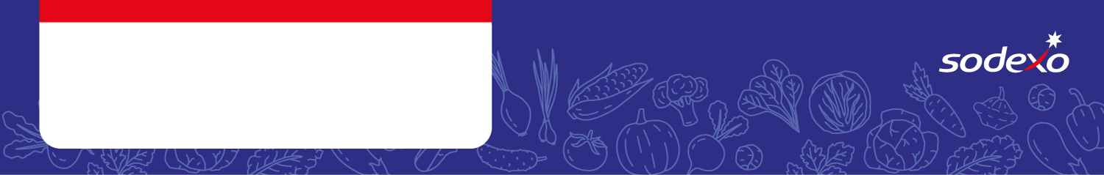
Food Safety Management System
Forms
Week 3

Menu Item   Tick the allergens that are in the dish  Insert ‘MC’ where the label states ‘May Contain’ | Celery | Cereal  containing  gluten * | Crustaceans | Eggs | Fish | Lupin | Milk | Molluscs | Mustard | Nuts** | Peanuts | Sesame seeds | Soya | Sulphur  Dioxide &  Sulphites
Cheese Pizza, New Potatoes |  | Wheat |  | MC
Cauli & Broccoli Bake, New Potatoes |  | Wheat
BBQ Chicken, Wedges |  | Wheat/ Barley
Summer Vegetable Taco, Wedges |  | Wheat
Roast Chicken Dinner & Gravy

Vegetable Sausage & Roast Potatoes |  | Wheat
Pasta Bolognese & Garlic Bread |  | Wheat |  |  |  |  | MC |  | MC |  |  |  | MC
Piri Piri Mince & Pitta Bread |  | Wheat |  |  |  |  |  |  |  |  |  |  | MC
Fish Fingers & Chips |  | Wheat
Quorn Nuggets & Chips |  | Wheat

