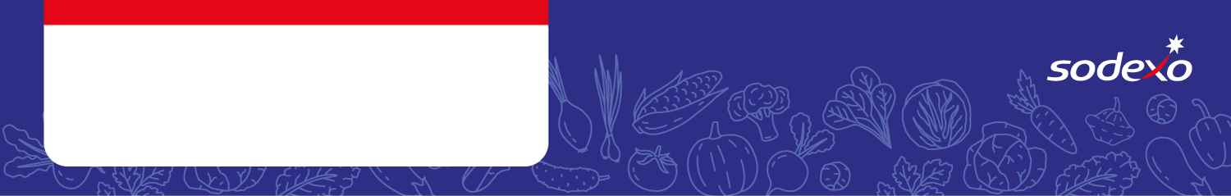
Food Safety Management System
Forms
Week 2

Menu Item   Tick the allergens that are in the dish  Insert ‘MC’ where the label states ‘May Contain’ | Celery | Cereal  containing  gluten * | Crustaceans | Eggs | Fish | Lupin | Milk | Molluscs | Mustard | Nuts** | Peanuts | Sesame seeds | Soya | Sulphur  Dioxide &  Sulphites
BBQ Chicken Wrap & Rice |  | Barley/ Wheat
Sweet Potato & Chickpea Curry & Rice
Stir Fried Vegetable & Noodles

Leek, Cheese & Potato Pie & Wedges
Roast Chicken Dinner & Gravy

Veggie Sausage Roll, Roast Potatoes & Gravy |  | Wheat
Creamy Chicken Pasta & Garlic Bread |  | Wheat |  |  |  |  |  |  | MC |  |  |  | MC
Veggie Meatballs & Spaghetti & Garlic Bread |  | Wheat |  |  |  |  |  |  | MC |  |  |  | MC
Breaded Fish & Chips |  | Wheat
Breakfast Wrap & Chips |  | Wheat

