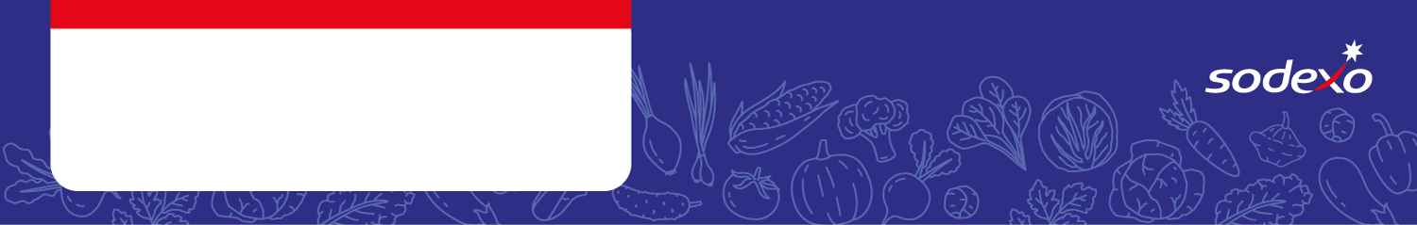
Food Safety Management System
Forms
Week 1

Menu Item   Tick the allergens that are in the dish  Insert ‘MC’ where the label states ‘May Contain’ | Celery | Cereal  containing  gluten * | Crustaceans | Eggs | Fish | Lupin | Milk | Molluscs | Mustard | Nuts** | Peanuts | Sesame seeds | Soya | Sulphur  Dioxide &  Sulphites
Pork Sausage, Mash & Gravy |  | Wheat
Quorn Sausage, Mash & Gravy |  | Wheat
Chicken Burger & Wedges |  | Wheat |  |  |  |  |  |  |  |  |  | MC
Plant based Cheeseburger & Wedges |  | Wheat |  |  |  |  |  |  |  |  |  | MC
Roast Chicken Dinner & Gravy

Summer Quiche, Roast Potatoes |  | Wheat
Macaroni Cheese, Garlic Bread |  | Wheat |  |  |  |  |  |  | MC |  |  |  | MC
Tomato Pasta, Garlic Bread |  | Wheat |  |  |  |  | MC |  | MC |  |  |  | MC
Fish Fingers & Chips |  | Wheat
Pizza Pinwheel & Chips |  | Wheat

